Team members: Brennon Franklin, Ben Miller, Joshua Wye, Tony Hoang.

The task presented before the team was to modify the traditional game of noughts and crosses to include elements of chance whilst still resembling the original game. Through careful deliberation it was decided that the game should include questions that would be chosen from a random category which would be decided by a roll of the die.

The game would be made up of two to four teams which would compete against each other to connect three of their pieces in a row. The order in which teams would take their turns would be decided by a die roll with the highest going first and the lowest going last. They would then roll the die to determine what category they would receive a question from. Any team member can answer the question and if they answer the question correctly, they would place a piece on the board.

The game consisted of six categories that would each consist of multiple questions each. The six categories were geography, entertainment, history, arts and literature, science and general knowledge. Each category was assigned a number to choose which category the die roll corresponded to. The categories each had different colour cards which would allow players to differentiate them.

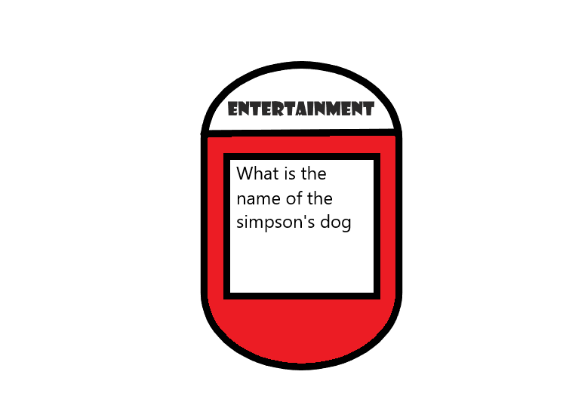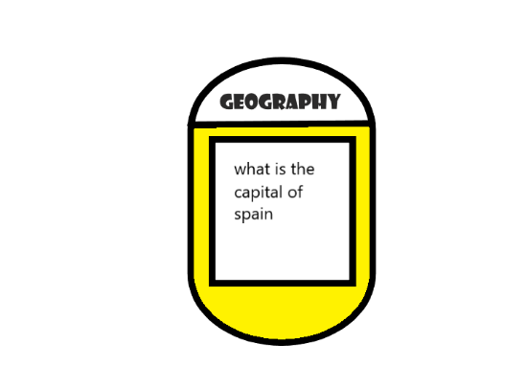

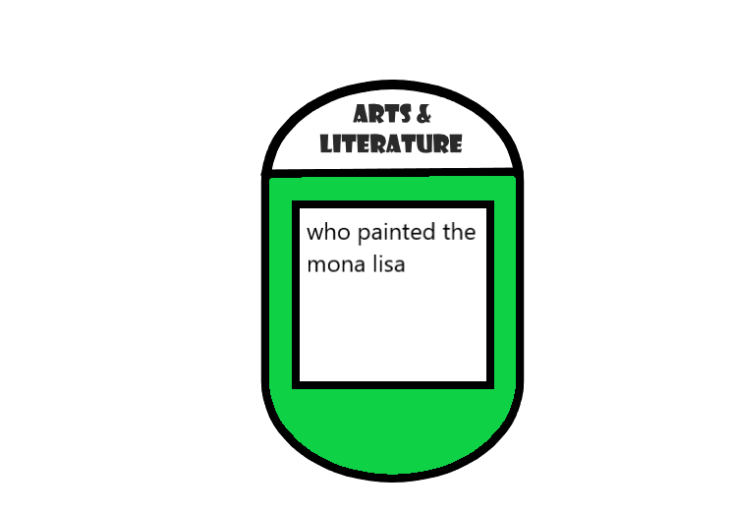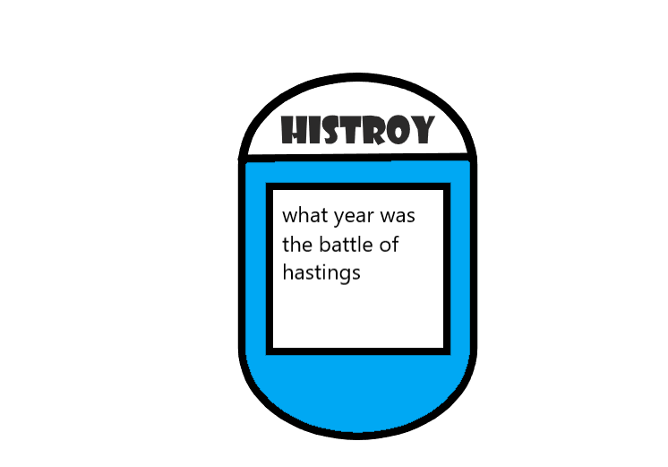

Figure 4, Arts & Literature Trivia Card

Figure 3, History Trivia Card

Figure 2, Entertainment Trivia Card

Figure 1, Geography

Trivia card

Example questions were created to give players a feel of what the completed game would be played like. Some of the examples were “What is the world’s largest continent?”, “Who Discovered America?”, “At what speed does light travel?” and “How many years have the Simpsons been running for?”. These questions were designed to be difficult to make the game more entertaining but not so difficult that they could not get a single question right.

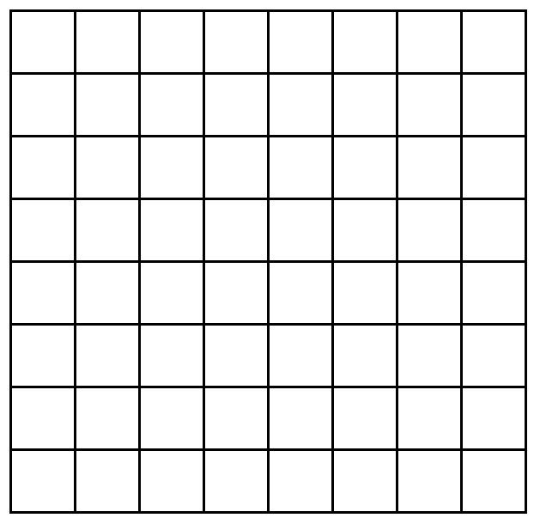The board design was created so that it could be changed depending on the number of teams that were to play the game. The size for two teams was designed as a six by six board while the board for four teams was designed to be eight by eight. The fact that the game was designed to include four teams meant that more pieces needed to be added to the game. The game pieces included the original noughts and crosses with the addition of triangles and squares.

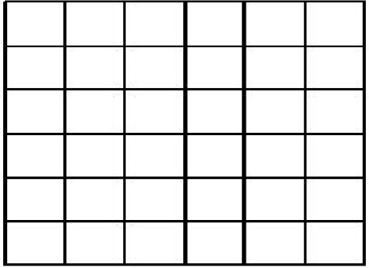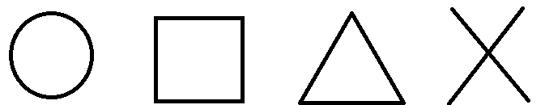

Figure 5, Shapes

Figure 7, 8x8 Board for 4 teams

Figure 6, 6x6 Board for 2 teams.

The team was unable to perform external play testing but was able to perform the testing internally. The game functioned as intended, however, questions were found to be way too difficult for the players to answer and this led the team to reconsider the questions that would be included into the game. The team also decided to add in a steal system that would allow the other players to answer the questions if the opponent got the question wrong.